BIT 4107 – MOBILE APPLICATION DEVELOPMENT
ENHANCED PROFESSIONAL STUDENT LOGBOOK
STUDENT NAME: SHALOM KIBOKO
ADMISSION NUMBER: BIT/2025/39237
SCHOOL/FACULTY: COMPUTING AND INFROMATICS
PROGRAMME: BACHELOR OF SCIENCE IN INFORMATION TECHNOLOGY
ACADEMIC YEAR: 2
SEMESTER: 2
LECTURER: MR.NYORO MICHAEL
PHONE NUMBER: 0725865117

Week 6 Title:
Networking in Mobile Applications
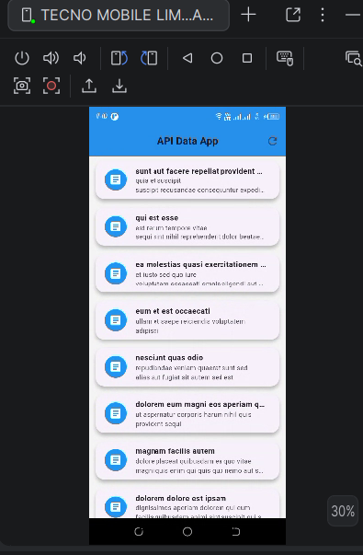
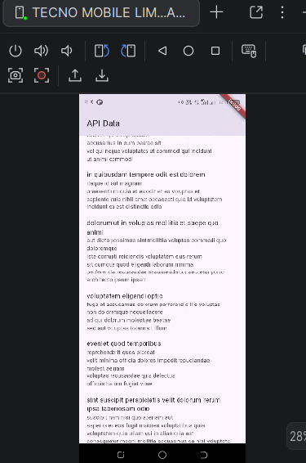

Figure 1: API data

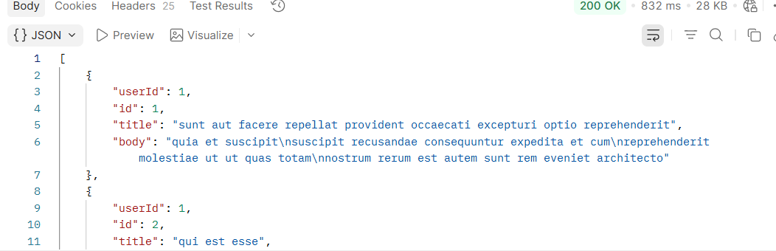
Figure 2: Postman request

Figure 3: JSON response data

Task 3: JSON Creation
{
"regno": "BIT39237",
"name": "SHALOM",
"course": "BIT",
"year": "3"
}

